**Faithful Teaching**

**August 2016**

**Faithful Teaching at Whittier Christian High School**

The possibility and project of integrating the Christian faith with secular learning has been on the minds of Christian educators at least since the time of St. Augustine, and more recently among evangelicals with the publication of Frank Gaebelein’s 1954 book *The Patterns of God’s Truth*. The task of integrating faith and learning has generated a vast academic literature, as a simple Google search on “bibliography on the integration of faith and learning” will reveal. The conversation continues to this very day. Clearly, as this deep and wide-ranging conversation suggests, Christian educators and scholars deeply care about what precisely it means to integrate faith and learning. At the same time, there is a frustrating lack of consensus about both how to define the integration of faith and learning and what it looks like in practice, as Whittier Christian High School’s experience during the 2015 ACSI/WASC accreditation visit confirmed.

For reasons that we will explain below, we recommend that WCHS abandon the language of integration of faith and learning and adopt a vocabulary associated with the idea of faithful teaching. Furthermore, we believe that faculty, coaches, student group advisors, program directors, staff, and administration at Whittier Christian, current and future, need to perform the hard intellectual work of identifying the theological, epistemological, psychological, and anthropological assumptions of his or her role as a Christian educator.  In addition, we do not think this is a once for all, one and done, enterprise. Faithful teaching is not a static sort of thing, and we need engage these things at various stages of our teaching careers.

Our task is to help provide the necessary vocabulary and questions, the “tools” if you will, to enable and assist faculty, coaches, student group advisors, program directors, staff, and administration in this task of intentionality.  Our goal at this stage is to offer a gateway into what faithful teaching looks like in the classroom, on the athletic field, in the performing arts venue, and in the school office.  What we seek to do is assist you as individuals and as departments in that difficult task. In the discussion that follows, we offer a set of questions to help us think about our individual theological, epistemological, psychological, and anthropological commitments that guide our teaching.

In addition, we recognize, even insist, that faithful teaching looks a little different for each individual.  Why is that?

1. As Christians, we clearly share fundamental theological commitments such as the divinity of Christ, his birth, death, and resurrection; at the same time as faculty at a non-denominational school, we each hold to theological positions that vary from individual to individual, denomination to denomination.

2. In addition, we each have different life stories and are at different places in our Christian walk: indeed, the Holy Spirit isn’t finished with any of us yet.

3. Furthermore, each of us has been trained in a specific academic discipline, and we have commitments to how that particular discipline frames questions, understands evidence, and constructs arguments.

4. Finally, each of us has a different role at Whittier Christian in terms of our job descriptions, our understanding of the school’s mission statement, and the contexts in which we interact with students.

We cannot offer prepackaged answers to the question of faithful teaching; instead, we must find our own answers in collaboration with other teachers within and without Whittier Christian, with other Christians past and present. Such is the challenge of faithful teaching.

**Part One: Critique of the Integration Approach**

In this first section, we want to briefly describe the various ways Christian educators and scholars have understood integration of faith and learning or Biblical integration.  Furthermore, we will argue that “integration” language is inadequate for our purposes. In the next section, we will offer an alternative language that encompasses more of what we do as Christian educators.

**Models of the Integration of Faith and Learning**

One Model of the Integration of Faith and Learning: Christ Against Culture

The Christ against culture model is the idea that the Christian faith and pagan learning cannot be integrated, that the religious realm and the secular realm exist not just separate from each other but more often than not in opposition to the other. The emphasis of this first model is on separation, distinctness, and uniqueness of the content of Christian education.

According to the Christ against culture model, an educational institution chooses one of the two sides: religious or secular.  There is not room for both approaches within academic knowledge.  Richard Langer, the Director of the Office of Faith and Learning at Biola University, uses the archetypes of a philosopher and a preacher to illustrate the separate nature of these two kinds of learning.  A philosopher wholly embraces all things science and philosophy and in turn, necessarily rejects all things religious.  Likewise, the preacher in embracing all things religious and faith-based must reject all things secular.

The tension between these two antagonistic approaches results in a “suspicion” between the two.  One must be right, so the other must be wrong. Consequently, the practice often involves rejection, isolation, and/or reformation of secular knowledge. The Christ against culture model views scriptures as the principle source of knowledge in all academic areas. Consequently, the Christ against Culture model argues that secular academic approaches are based on inadequate foundational beliefs and thus are epistemologically suspect and lead to faulty knowledge observes Susan VanZanten, Professor of English at Seattle Pacific University.

In practice, the Christ against culture model only allows overlap of Christian faith and secular learning when it benefits the chosen religious emphasis.  For example, scientific findings are only accepted when they correspond with and illustrates/clarifies a particular Biblical teaching. An example of this approach is scientific creationism.

A Second Model of the Integration of Faith and Learning: The Two-Spheres Approach

The two spheres model suggests that both the Christian faith and secular learning are highly valuable but comprise separate epistemological domains. The idea here is a heterogeneous perspective to knowledge; that is, there are many valid sources of truth. The two spheres model is also variously known as the separate but equally important approach, the separate but equal model, the complementary approach, and the valued added approach.

The two spheres model acknowledges various sources of knowledge without blending or masking distinctions. In this way, each source of knowledge is allowed to speak separately and in its own idiom. Langer proposes a “candlestick maker” metaphor, in that a candle is made up of distinct parts such as wax and wick. For example, John Wesley recognizes four sources of knowledge: scripture, reason, tradition and experience. Each is understood through fallible human faculties, and cannot be merged into an encyclopedic whole. Wesley keeps the sources of knowledge distinct and weighs them against one another in a kind of synergistic proximity.

VanZanten highlights several ways the two spheres approach can be manifested. One is a two-pronged approach: different members of the school are mainly responsible for each component. Teachers impart disciplinary knowledge in a caring and considerate manner. The school provides opportunities for Christian practice embedded into the learning experience, such as chapels or community service projects in which teachers may or may not participate or facilitate. The two spheres of knowledge and experience are kept separate while each are experienced by all in the school community.

A second approach noted by VanZanten is the value-added approach. Here, secular and Christian knowledge intersect and enrich each other without interfering with each other. They are separate realms of experience, each a necessary part of the human-Christian experience. This approach has a venerable tradition. For example, St. Thomas Aquinas describes a civilian government, founded on the classical virtues of prudence, temperance, justice and fortitude, enhanced by the theological virtues of faith hope and love. Each set of virtues has separate origins, Greek and Christian, yet both are essential to a healthy, well-run society.

In a Christian school, this approach may see learning a discipline as preparation for a professional or vocational calling, such as studying anthropology to enhance missionary work or studying public relations with the aim of running a Christian organization or relief agency. In addition, values taught in a Christian school can influence elements of professional practice. For example, while accounting is accounting however one looks at it, the Christian ethics of the practitioner impact the execution. Work related decisions such as product design, wartime decisions involving prisoners and torture, or similar professionally oriented ethical concerns can be raised during the study of a particular discipline in a Christian academic setting.

A Third Model of the Integration of Faith and Learning: The Intersection of Faith and Learning

While the concept might be at least as old as the project of “natural theology,” the phrase “integration of faith and learning” was perhaps first used 1954 by Frank Gaebelein in *The Pattern of God’s Truth: The Integration of Faith and Learning,* and strongly reinforced by a group of scholars that included Francis Schaeffer, Carl F. Henry, Arthur Holmes, and Harry Blamires among others.  Gaebelein offered a corrective to what he saw as a truncated view of the Christian faith as merely personal and ethical, limited to worship and devotion. He was responding to the separation of facts and values, the separation of science and faith, the separation of secular and sacred that characterized modernity at the mid-twentieth century. These scholarly claimed that the distinction between facts and values is specious; evidence and theory are all driven by values. Gaebelein called Christians to see that “faith had everything to do with teaching and academic research.” Our faith, Gaebelein argued, informs the questions we ask, the evidence we count, and the answers we reach.  In the years that followed the publication of Gaebelein’s book, the “integration of faith and learning” and “biblical integration” became educational mantra at evangelical, mission-driven schools, colleges, and universities.

We can understand the task of integrating faith and learning as part of a larger project to integrate knowledge that seemed unnecessarily fragmented and without unity, largely the result of academic specialization.  We can see evidence of integrative activity the tradition of broad cross-disciplinary learning characterized by various great books programs, first begun at Columbia, Chicago, and Boston University in the 1930s and 1940s, and continues in over one hundred universities including Biola’s Torrey Honors Institute. In addition, the integrative project can be seen in the cross-curricular and interdisciplinary curriculum efforts at the elementary and secondary level during the 1940s and 1950s.

For Christian educators, the core of this integrative project is the assumption that “all truth is God’s truth,” and that any separation between faith and knowledge is apparent, not real. The integrative project, then, has been to bring together two distinct entities: faith and knowledge.  Christians are to compare the assumptions of the various academic disciplines to the assumptions of the Christian faith, looking for agreement and reconciling perceived differences. In this model of faith and learning, the task of Christians is to re-integrate what others have mistakenly separated.

A Fourth Model of the Integration of Faith and Learning: Worldview Analysis

While perhaps not precisely a separate approach to integration, as it draws from the Christ against culture model and the intersection model, the worldview analysis model deserves mention. According to James Sire, former editor for InterVarsity Press and author of *The Universe Next Door*, “a worldview is a commitment, a fundamental orientation of the heart, that can be expressed as a story or in a set of presuppositions (assumptions which may be true, partially true or entirely false) which we hold (consciously or subconsciously, consistently or inconsistently) about the basic constitution or reality, and that provides the foundation on which we live and move and have our being.” In this model of integration, all academic work in an academic discipline is viewed from a particular worldview or perspective. Coherence is achieved by fitting all elements of a discipline into a larger framework of thought and practice.

This view assumes that there is a unity of all truth within each worldview system. The Christian worldview claims that there is an all-encompassing Truth in which all other truths fall. Such a view may emphasize a Christ against culture model, where students are taught Christian worldview is superior to other worldviews. Alternatively, worldview analysis might stress the integration of Christian and secular knowledge under the premise that all truth is God’s Truth. In both cases, the focus is to assist students to grow intellectually and embrace the one Christian worldview. Worldview analysis rarely incorporates the two spheres model. This approach is how our Worldviews course is taught at WCHS. The goal is to learn a set of propositions that reveal the Christian worldview. The Christian worldview is studied and compared to other worldviews.

**A Critique of the Biblical Integration Model and Language**

When we started this project, we were fairly confident that we would discover precisely what the language of “Biblical integration” and “the integration of faith and learning” meant. Unfortunately, such was not the case. As suggested by the various models described above, the whole integrative project has been widely divergent to a remarkable degree. That is, we came to realize that the vocabulary of integration means many different things to many different people. We found it a mistake to assume that the vocabulary of “integration” has the same meaning for all those who employ it.  Furthermore, we discovered that the usage of the term “integration” constitutes a poor guide to how others understand their position.  For example, differing meanings of integrative language led to fundamental misunderstandings between members of the 2015 ACSI/WASC visiting team and WCHS administration and faculty.

In addition, we observed that integrative language inadequately describes all of what we do as Christian educators. One shortcoming is the integrative project itself. The language of integration, either theoretical or in practice, suggests that two distinct entities (facts and values, science and faith, the secular and the sacred) somehow need to be brought together in some shape or form. While the integrative model is an important and necessary approach in some cases, it lacks clarity in its application to many disciplinary contexts, such as to a basic course in chemistry, a first year calculus class, or a lesson on elementary French grammar. This lack of clarity often leads to uncertainty and frustration for many teachers.

Integrative language also implies that Christian education is always essentially different from other forms of education. Integrative language can often lead us to ask in what ways is what we teach in the classroom distinct from what is taught in non-Christian schools. We are not convinced that this is the right question to ask.

Furthermore, integrative projects typically narrow the activity to the work of academic or disciplinary concerns. All that matters is bringing the two elements, faith and the subject matter, together and our work is done. That is, integration speaks to the content of Christian education, not necessarily to its goal.

Finally, and perhaps most importantly, integration language does not necessarily point us to think Biblically or theologically about who we teach or how we teach. That is, the integrative project, which is primarily concerned with curricular matters, does not speak to full range of what we do as Christian educators nor does it help us understand our students or our methodologies.

We are not arguing that the projects of faith-learning integration need to be abandoned. Indeed, we found the commitment among Christian scholars and educators to integrate both their faith and their academic discipline commendable and worthwhile. The integration of faith and learning results from a deep sense of tension between two things we care about and an admirable desire to relieve the tension in some acceptable fashion. Nevertheless, we argue that the integrative project be subsumed within a more expansive topographical schema that captures most if not all of what we as Christian educators. Therefore, we suggest that WCHS abandon integrative language, although not its projects.  We recommend adopting a language that not only captures the various integrative projects and at the same time is inclusive of all that we do as Christian educators.

**Suggested Reading**

Allen, Patrick and Kenneth Badley. *Faith and Learning: A Guide for Faculty*. Abilene: Abilene Christian University Press, 2014. Especially Chapter 2: What Is All the Faith and Learning Fuss About?

Langer, Richard, “The Discourse of Faith and Learning.” *JECB* 16:2 (2012): 159-177.

VanZanten, Susan. *Joining the Mission: A Guide for (mainly) New College Faculty*. Grand Rapids: Wm. B. Eerdmans Publishing Company, 2011. Especially Chapter 5: The Faithful Professor: Multiple Paradigms for Faith and Learning.

Wolfe, David. “The Line of Demarcation between Integration and Pseudointegration.” In *The Reality of Christian Learning: Strategies for Faith-Discipline Integration,* edited by Harold Heie and David Wolfe, 3-11. Eugene: Wipf and Stock Publishers, 1987

**Part Two: Faithful Teaching**

We would like to offer an alternative vocabulary that more fully captures what we do as Christian educators: a vocabulary of ***faithful teaching***.  In offering this vocabulary, we are intentionally echoing the language of Nicholas Wolterstorff, who taught for many years at Calvin College and Yale Divinity School and coined the terms “faithful learning” and “faithful scholarship.” We believe that a language of faithfulness offers a vocabulary that captures more broadly than integrative language what we do as Christian teachers at a Christian school. In addition, the language of faithful teaching does not suffer from the inadequacies of integrative language. We have selected faithful teaching because it encompasses all of our craft as teachers in ways integrative language does not.

**The Concept of Faithful Teaching**

We think that Wolterstorff’s approach is a better reflection of what we are trying to accomplish at Whittier Christian High School.  Overall, Wolterstorff has a strong commitment to Christian education and believes Christian education is worthwhile.  His vision for education is a kind of education that results in human flourishing: “people living in right relationships with God, with themselves, with each other, and with nature, and taking delight in such relationships.”  In this context, Wolterstorff writes about faithful learning, which he explains as “Christians … be(ing) faithful in their scholarship - faithful to their Lord, faithful to their fellow believers, faithful to their fellow human beings, faithful to the earth.”  In its most basic form, faithful teaching captures the practice of fidelity to the gospel in all areas of our teaching.

By adopting faithful teaching and moving away from language such as Biblical integration and the integration of faith and learning, we can avoid misunderstandings that occur when we mistakenly assume we all understand the terms the same way.  In this case, by employing faithful teaching instead of integration of faith and learning or similar language, we invite others to ask questions about what we mean and thereby reduce misunderstanding.

The language of faithful teaching invites us to ask how our teaching is intentionally faithful to the gospel, and moving us away from the question of how our teaching is different. Integrative language leads us to ask how are Christian schools different from non-Christian schools.  The aim of teaching faithfully is fidelity to the gospel, not necessarily to be different or distinctive.  As Wolterstorff observes, “Let the differences fall out as they may . . . Fidelity in the field of scholarship will yield plenty of difference. But difference is not the goal; indeed, Christian scholars should be delighted when others accept their view.” In much the same way, Susan VanZanten, who has adopted the language of “the faithful professor,” writes, “Sometimes Christian and non-Christian scholars will be in agreement; other times they will not. Sometimes Christian teachers will facilitate learning in exactly the same way as non-Christian teachers; other times they will not.”

Faithful teaching may bring us to ask questions about how scientists and musicians understand their vocation in a theological context, seek out how to coach with fidelity to Christ’s message, or consider the implications for our teaching when we see our students as bearing God’s image. In this way, a classroom in a Christian school might look very different from other alternatives.

Yet, a presentation on cell division, instruction on the eight sentence paragraph model, coaching a skill in volleyball, or modeling proper breath support in vocal music may look the same in a Christian and non-Christian setting.  Because we are all (believers and non-believers alike) created by the same Creator God and share the same created reality, it makes sense that we not only have the same desire to understand the world around us but that our projects at some points may very well look the same. Faithful teaching involves honoring the innate abilities we have and being faithful to the gospel in our scholarship. The goal is not necessarily to be different or distinctive, but to be faithful in our teaching.

The language of faithful teaching also invites us to go beyond *what* we teach to consider *who* and *how* we teach.  Unlike integrative language which points us merely to the content of our teaching, faithful teaching encourages us, in light of Christ’s teaching, to consider the ways we teach and how we see our students without abandoning the necessary and worthwhile projects of the integration of faith and learning.

The language of faithful teaching invites us as Christians to faithfully engage in the content of our disciplines in the particular form in which we find it in our time and place.  At the same time, it also invites us to engage our students and each other in ways that are faithful to the gospel.   In this way, the language of faithful teaching encompasses much more than *what* we teach.  While integrative language points us toward subject matter content and epistemic concerns, faithful teaching invites us to go beyond and ask questions about *how* we teach and *who* we teach, areas that integrative language tends to leaves out.  What we teach is important, and faithful teaching captures the necessary and worthwhile projects of integrating of faith and learning; that is, to faithfully engage the content of our disciplines, in the particular form in which we find it, in our particular time and place. At the same time, the language of faithful teaching invites us to consider, in light of Scripture and Christian thought, the ways in which we teach and the ways in which we see our students.

In its most basic form, faithful teaching calls us to be intentionally faithful to the gospel in all areas of our teaching. Faithful teaching should orient our work as teachers around being faithful to our Lord, being faithful to our fellow believers, being faithful to our fellow human beings, and being faithful to God’s creation.

**A Gateway to Faithful Teaching**

We have developed a diagram as entryway into the kinds of questions we need to ask ourselves as we think about faithful teaching.  The diagram is not faithful teaching, but instead it is tool to help us discuss faithful teaching among ourselves here at Whittier Christian and with those outside of Whittier Christian.

First off, we want to stress that this pyramidal diagram is not faithful teaching, as such. We have no intention of reifying faithful teaching. We do want you to confuse the model with reality; as was once famously said “the map is not the territory.” To paraphrase for our situation: “the diagram is not faithful teaching.” We have developed this particular diagram as a gateway into the kinds of questions we need to ask ourselves as we think about faithful teaching.  The diagram cannot possibly *be* faithful teaching, but instead it is *tool* to help us think about and discuss faithful teaching. Furthermore, we recognize that it is not the only possible tool. Surely there are other fruitful ways to conceptualize this very complex process. Nevertheless, we have chosen this approach because it does offer a conceptually sound framework, a common language, and specific vocabulary by which we can meaningfully discuss how to be intentionally Christian teachers at a Christian high school.

The idea is to use the diagram as the starting or entry point for *intentionality*, not an ending or exit point. Perhaps it is helpful to think about this in terms of the name of our school. Whittier Christian High School is firstly a school (n.). And as a school, it is imperative for us to do certain things well. We are quite intentional about what we want to see in our students. We do this very well. The rest of the name of our school, Whittier, Christian, and High, are all adjectives that tell us more about the kind of school this is. The adjective “Christian” specifies a particular kind of school, another area in which we need to be intentional. Whatever it was that the ACSI/WASC people expected to see or not see, their overall point was that *as a particular kind of school, a Christian school, we are not quite as intentional as we might be or claim to be*. The key to faithful teaching is intentionality.

Some might disagree about this aspect of intentionality - that one cannot plan for the work of the Holy Spirit in the lives of our students, or for spiritual development, and so on. While there is an aspect to such thinking that makes sense, we can still argue that Scripture suggests intentionality in many respects: see for example Act 16; Proverbs 14:13; Proverbs 23:3; Psalm 127:1. Perhaps it is helpful to think about spiritual formation as a kind of music – jazz music, tight control of instruments and music yet allowing space for improvisation, interplay, and influences. In any case, what this diagram offers us is a way to consider three areas where we can be intentionally Christian in the context of a Christian high school.

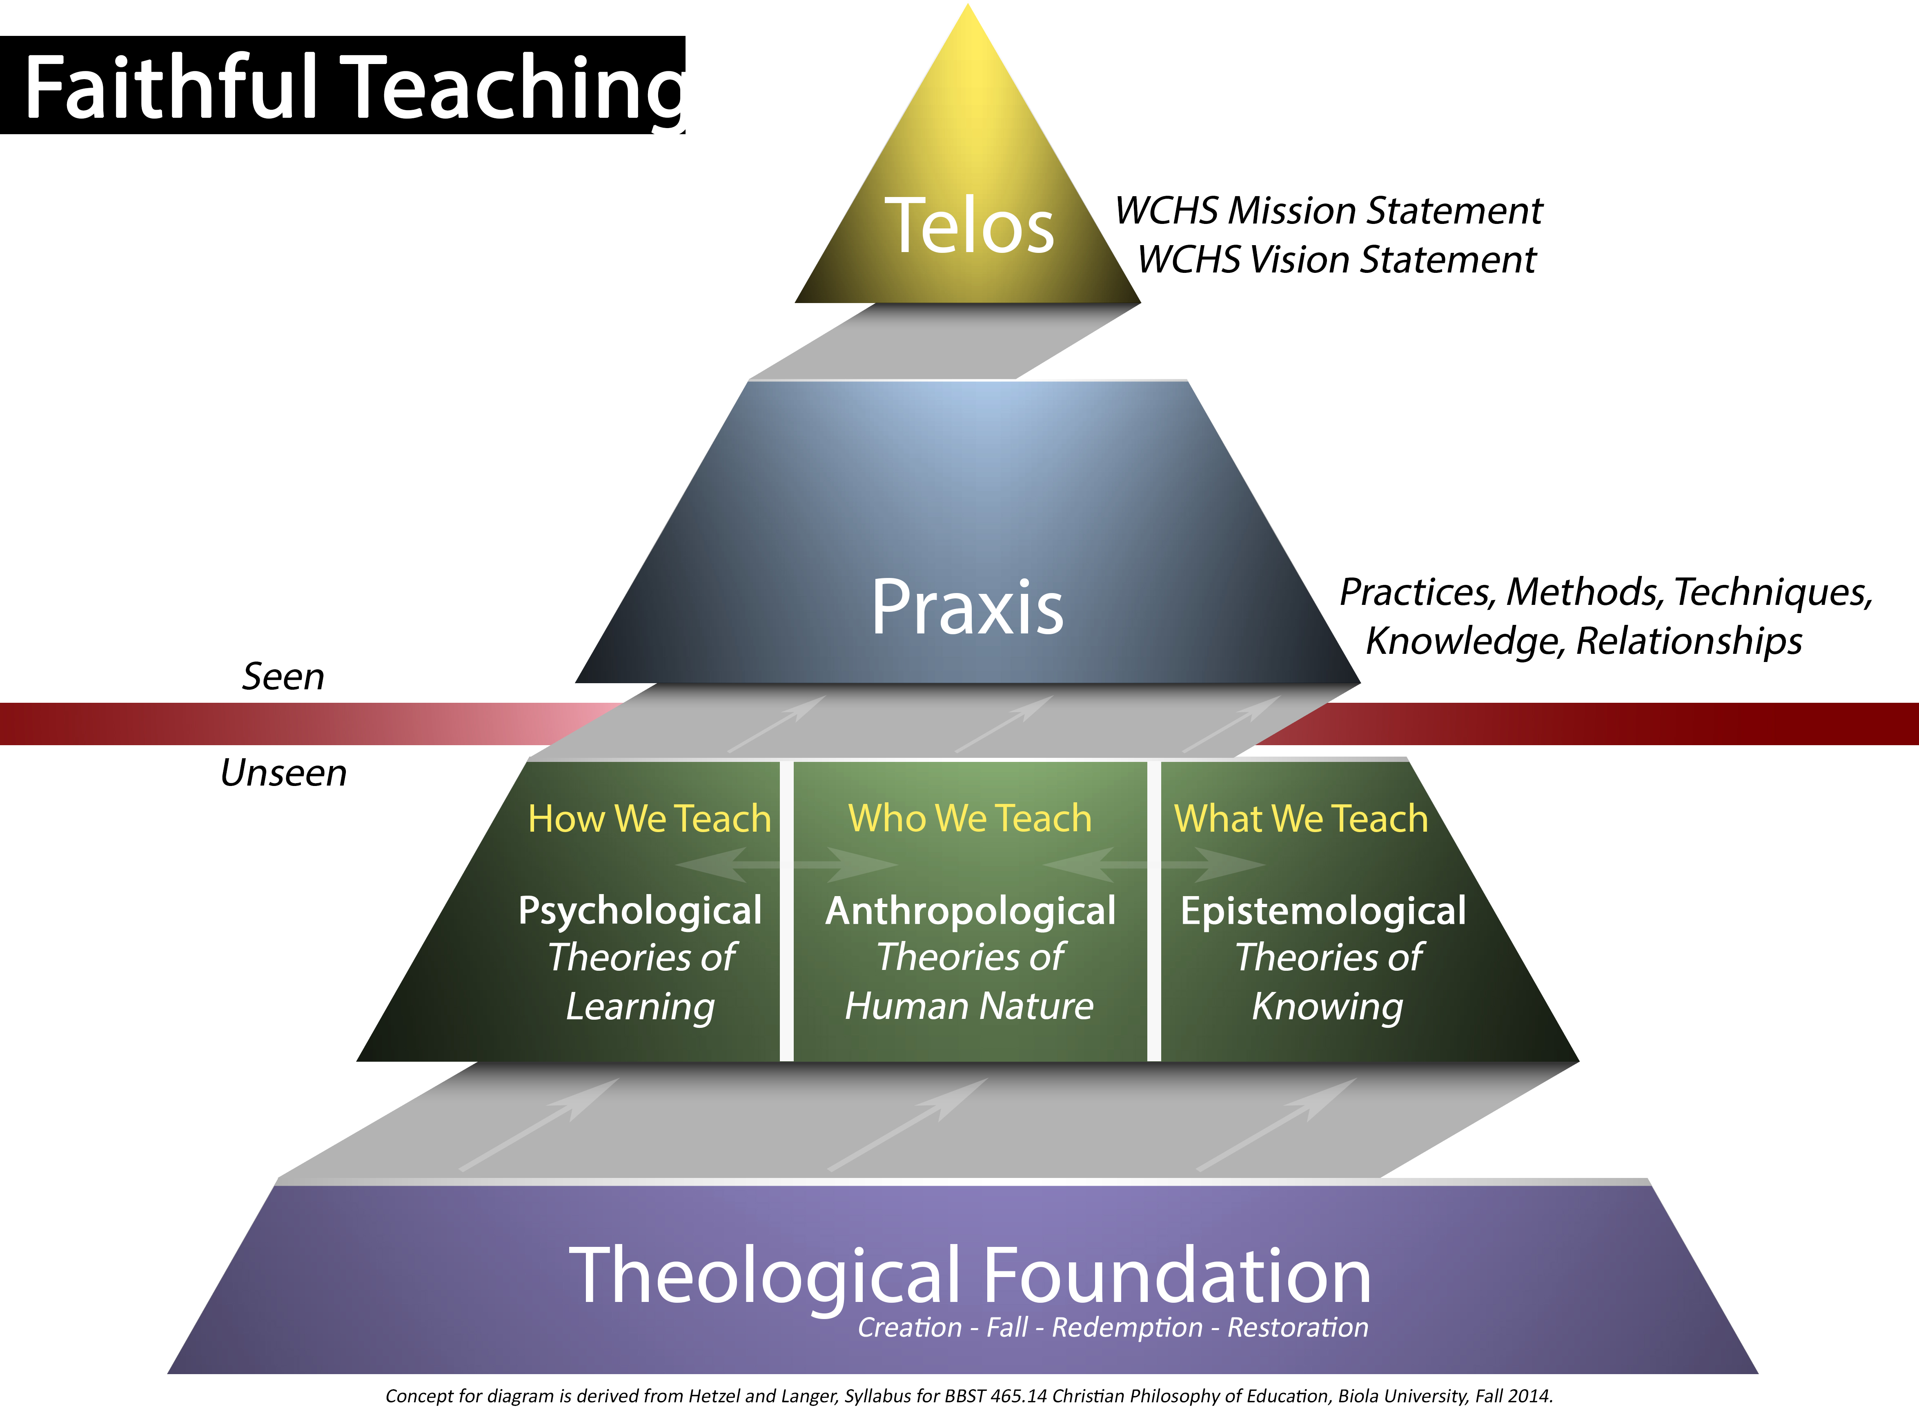

***Telos***. At the apex of the pyramid, we have the teleological aspect of WCHS: our goals as a school. These are captured in our Core Values, our Mission Statement, and our Vision Statement. In the terms of current sociological terminology, these ends and goals are linked to “human flourishing.” Our Core Values, our Mission Statement, and our Vision Statement were developed by a team of board members, administrators, faculty, and parents a number of years ago. They are posted all over the school, we have tasks to complete that address the core values; that is, we are quite familiar with them. In some ways, they describe characteristics that (hopefully) define our school. Mostly, though, they describe the ideal WCHS graduate. We intend them to be visible in the lives of our students. The rest of the pyramid suggests how that happens.

***Praxis***. In the center of the pyramid is an area termed praxis: practices, methods, techniques, knowledge, and relationships. These are the visible things that happen in the classroom, during rehearsals and performances, on the athletic fields, in Herald Hall, in the Leon Davis Event Center, in the school offices, during service projects, and at ASB events.

They are seen in our instructional methodologies and practices as they are played out with our students. They are seen in the everyday interactions between our students and ourselves, and are made visible in our relations with students. Faithful teaching suggests both best practices as an educator and best practices as a Christian. The point is to suggest an intentionality regarding what we do in this respect.

***Anthropological, Epistemological, and Psychological***. Telos and Praxis are generally visible to our student, visitors, and us; the bottom half of the pyramid suggests activities that are not generally seen. They occur in the mind and in the heart. They are intellectual activities we perform at our desks, while exercising, or reading at the park. Often, they occur while on our knees before God in prayer and worship.

They can be organized into three categories: Anthropological, Epistemological, and Psychological. These categories suggest different sorts of relationships and engagement broadly conceived. We think they capture the range of things we do as Christian teachers at a Christian school.

At the center is the question of “Who We Teach,” which considers the anthropological aspects of our teaching. How do we understand those people arrayed around us during class, practice, rehearsal, school activities, or lunch? What insights can we gain by examining theories of human nature? In what ways are we intentional about integrating our theories of human nature with our theological commitments, and to what degree do they influence how we relate to our students?

Next is the question of “What We Teach?” Here we want to consider the epistemological concerns that inform our disciplinary tasks. Each of us has been trained in a specific academic discipline, and we have commitments to how that particular discipline frames questions, understands evidence, and constructs arguments.  In what ways are we intentional about integrating our disciplinary commitments with our theological commitments, and to what degree do we make that transparent to our students?

Finally is the question of “How We Teach?” We need to make sense of the descriptive psychological theories on how students learn. In what ways are we intentional about integrating psychological insights into how our students learn with our theological commitments, and to what degree do they actually inform the methodologies we employ in the classroom?

We recognize that there is significant overlap between these categories, but we believe it is useful to separate them out as a way to be more intentional out how we approach our task as a Christian teacher.

***Theological Foundation***. Our claim is that how we think about these three categories is, or should be, deeply informed by Christian theology and Biblical principles.

Interestingly, when we originally embarked on this journey together, we thought that there would be quite distinct and different theological questions informing each of the three categories (anthropological, epistemological, and psychological). The more we read, thought, and discussed, we found that the grand Biblical narrative arc of the creation, the fall, redemption, and restoration provided similar questions for each category.

At first we did not understand what we were seeing, which lead to some frustration due the strong overlap between the categories. For a while we wondered if the entire discourse was mere semantics and word play, a waste of our and your time. However, once we recognized the rich and fruitful interconnectedness between the Biblical narrative and our categories of anthropology, epistemology, and psychology, we were immediately more confidence that we were heading in the right direction. For some of us, it gave us yet another way of thinking about the unity of truth. In retrospect, it seems so obvious. But that is the nature of learning and discovery.

Our point is that the ways in which we understand the grand Biblical narrative arc of creation, the fall, redemption, and restoration, both collectively and individually, should inform our understanding of who we teach, how we teach, and what we teach. Notice that we are not mandating any specific understandings or positions with respect to the Biblical metanarrative. We think there are multiple theologically sound ways to think about implications of the creation, the fall, redemption, and restoration, all of them meaningful, fruitful, and enriching to ourselves and to our students. A good starting point for thinking about the Biblical metanarrative is Cornelius Plantinga, *Engaging God’s World: A Christian Vision of Faith, Learning, and Living.*

Creation.

Plantinga observes eight implications of the doctrine of creation, and several are particularly relevant to our role as teachers. He notes that no human being is beyond hope because the original goodness of creation implies that all of it is potentially redeemable. Everything made by God retains to some degree part of its original goodness and promise. “No human being is as good as he can be,” notes Plantinga, “but no human being is as bad as he could be either.” Furthermore, created things, including their parts and processes, while unique and at times mysterious, are also purposive and intelligible, Christians who have Scripture as a lens for viewing the world can hope to learn something of the Creator.

Plantinga also notes that the reality of *imago dei* implies wide ranging human responsibilities, many linked to stewardship and creativity. Furthermore, the Biblical pronouncement “let us create humankind in our own image” secures a range of human rights, not least of all personhood and human dignity. Similarly, C.S. Lewis considers the implications of seeing this “weight of glory” in our neighbors, and for us as teachers, our students.

Historically and theologically understood, there are three richly overlapping aspects of *imago dei*.

*Representational or Ontological View*

The most common view of being created in the image of God understands the image as consisting of characteristics within human nature. The inner psychological and spiritual qualities of humans are associated with, perhaps even analogous to, God’s. In this way, we are representational of God. This feature of humankind distinguishes us from the rest of creation. Being like God, we reflect His nature; that is, when one looks at a human being something of the nature of God shows through which can be seen nowhere else. This means, among other things, we are moral, relational, and spiritual beings endowed with creative, communicative, intellectual capacities.

*Relational View*

Another conceptualization of the image of God stresses the relational aspect of *imago dei*. The relational view suggests that we are most like God when it comes to our unique relational qualities. This view emphasizes that true humanity cannot be fully described in terms of the essential or ontological structure of the human being, but must also include humanity in actual existence. That is, *imago dei* is defined in terms of the relationships of man with God, with his fellow man, and with the rest of creation. Thus it is our ability to engage in complex interpersonal relationships that best reflects the divine. This is most evident when the God whom man images describes himself as “love,” which is clearly dynamic and relational.

*Functional View*

A functional definition of being made in the image of God centers on the God-given *task* for humanity to rule over creation, not so much a list of characteristics or relationships. We might think of this as being God’s representatives in the world. In Genesis, Adam received the commission to work the garden and become the *stewards* of God’s creation.  Just as God modeled work and purpose, He commissioned his creation to work purposefully for the maintenance and development of the created world.  Therefore, our responsibility to our creator is tied to our responsibility to the world. There is a necessary cyclical pattern to stewardship: we must be stewards in a way that we create future stewards.

The Fall.

Plantinga begins his discussion of the fall with this understatement: “Human life is not the way it’s supposed to be.” As Scripture teaches and the record of human activity demonstrates, we individually and corporately continually live our lives against what’s good for us. Why would we do that? Why would we act against the purpose of our own existence? Why do we struggle against the fact that we belong to God and not to ourselves? Why do we deny the idea that our lives themselves have come from God and therefore we owe God our gratitude and loyalty? Why do we continually will ignorance and self-deception? The fact of the fall and the presence of evil in the world present a number of implications for us as teachers. In particular, how do we come to grips with the knowledge that if the fallenness of creation extends far and wide then it extends into our very thinking processes? Furthermore, how do we come to grips with the realization that our understanding of the created world, the way we relate to each other including our students, the methods we use to teach, and our views of our students’ capacity to learn are all affected by this fallen state?

Redemption.

Believers are united with Christ through the power of the Holy Spirit and through the exercise of faith, itself God’s gift. In the New Testament, nobody gains union with Christ him- or herself alone. Even in private acts of devotion, meditation, and worship we are members of a worldwide and local body, joined with a whole realm of believers past, present, and future, a “cloud of witnesses.” Furthermore, baptism and communion bind us to Christ and each other, a body of people who do not necessarily get along well or even like each other very much. As Plantinga notes, originally some were Jews and some were Greeks. Some lean to the right in politics while others lean left. Some prefer contemporary church music while others long for the traditional. Yet, somehow we all fit into Christ. What are the implications of this for our classrooms? How does our understanding of redemption guide our relationships with our students, both those who are part of the body of Christ and those that are not? To what degree does redemption impact our understanding of and our relationship to the created world?

Restoration.

Part of the redemption story is that we are not just saved to go to heaven, but have been restored for better. God is doing a particular sort of work of reconstruction in the hearts, minds and lives of believers. As Amy Sherman states, “His story of the gospel doesn’t end with Christ’s sacrifice and our rescue (our ‘receiving our ticket to heaven’) … the conversation about salvation is linked to a conversation about discipleship.” We are not only saved from sin, hell and death, but we are saved for partnering with God in His work of restoring all things. We are to become partners with Jesus, to become “sent ones,” to join His heart and kingdom mission to promote shalom. Plantinga observes that “in the fellowship of the Christian community, the redeemed person embarks on a life’s adventure – to discover the purposes of God and to make them her own; to discover the ways of the kingdom and to follow in those ways; to uncover the ‘mind of Christ’ and to strive to become like-minded.” Thinking along these lines, how does the task of restoration play out in who we teach, what we teach, and how we teach?

We have offered a web of interconnected ideas as a gateway into thinking, discussing, and engaging what it means to be a Christian teacher. By presenting the language and vocabulary faithful teaching, our intent is to help us be intentional about our roles and responsibilities as teachers at a Christian school. In the section that follows, we will develop that language more fully as we examine in some specificity what we mean by the anthropological questions, the epistemological questions, and the psychological questions. In this way, we are proposing what we think are helpful questions, “tools” if you will, to point us in meaningful and fruitful ways to the task of intentionally faithful teaching.

We also recognize that this model of faithful learning is not the only approach. For example, David Smith, Susan Felch, and their colleagues at Calvin offer a compelling picture of Christian education centered on a rich web of Biblical metaphors that are deeply embedded in the historical tradition of Christian spirituality. Other writers such as Parker Palmer and Donovan Graham envision reconstructionist (even utopian) alternatives to Christian education that arrest our attention and force us to think deeply about who, what, and how we teach. Nevertheless, we think the language of faithful teaching captures the full range of what we do as Christian educators in the time and place into which God has placed us.

**Suggested Reading:**

Lewis, C.S. *The Weight of Glory and Other Essays.* New York: Collier, 1980.

Graham, Donovan. *Teaching Redemptively: Bringing Grace and Truth into Your Classroom.* Colorado Springs: Purposeful Design Publications, 2009.

Plantinga, Cornelius. *Engaging God’s World: A Christian Vision of Faith, Learning, and Living.* Grand Rapids: Wm. B. Eerdmans Publishing Company, 2002.

Palmer, Parker. *To Know As We Are Known: Education as Spiritual Journey.* San Francisco: Harper and Row, 1983.

Smith, David and Susan Felch. *Teaching and the Christian Imagination.* Grand Rapids: Wm. B. Eerdmans Publishing Company, 2016.

Smith, David and James K.A. Smith, eds. *Teaching and Christian Practices: Reshaping Faith and Learning.* Wm. B. Eerdmans Publishing Company, 2011.

Wolterstorff, Nicholas. *Educating for Life: Reflections on Christian Teaching and Learning*. Grand Rapids: Baker Academic, 2002.

Wolterstorff, Nicholas. *Educating for Shalom: Essays on Christian Higher Education*. Grand Rapids: Wm. B. Eerdmans Publishing Company, 2004.

**Part Three: Tools Toward Intentionality**

We would like to offer a series of questions one might ask relating to three “areas” of intentionality: who we teach, what we teach, and how we teach. We do not claim that these are the only questions one might ask; indeed, part of the task of faithful teaching is for each to ask the right questions that are specific to our individual circumstances. Furthermore, our goal here is not primarily theological. As we have noted earlier, we are not interested in mandating specific theological positions. Our point is that each of us needs to consider the *implications* of our theological and Biblical commitments for our teaching.

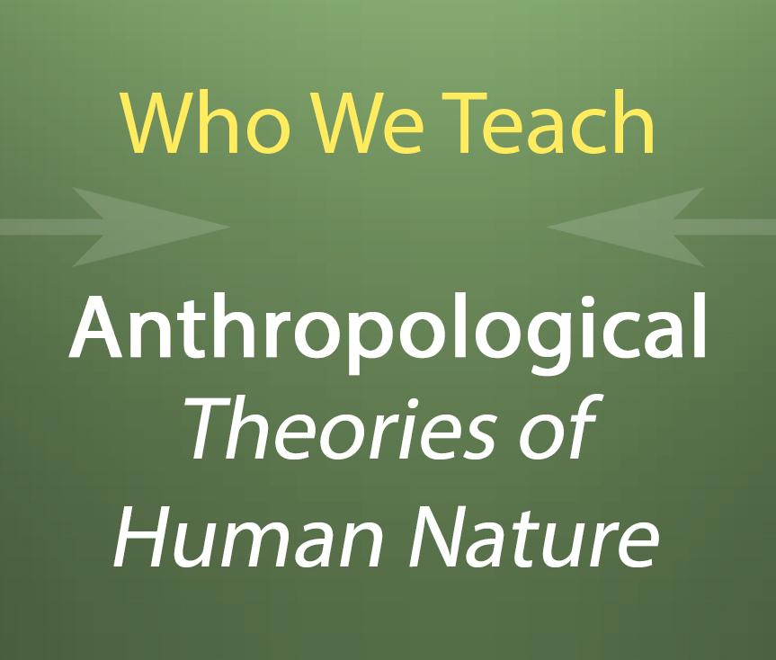I. Theories of the Person or the Anthropological Question: Who We Teach

Here we want to think about questions revolving around the people in our classrooms and on our teams? *Precisely who are those people in our classrooms? How do our theologies of human nature impact our understanding (and practices) of who we teach? In what ways do we understand and relate to our students in terms of the creation, the fall, redemption, and restoration?*

We want you to consider the nature of the relationships between student and teacher. Typically and not without good reason, as educators we think about our students as primarily thinking creatures. This model of the human person often assumes that learning is primarily a matter of depositing idea and beliefs into mind containers, if we infer from what we see and do in the classroom.

Yet, if we think about the two greatest commandments: to love God and to love our neighbors, we should conclude that mankind is not merely or even primarily a thinking being. Love is a relational term. The commandment to love suggests that we are designed to be in right relation with God and neighbor.

With this in mind, we might say that Descartes’s maxim “I think therefore I am” isn’t so much wrong as it is incomplete, because it reduces the human person to mere intellect. We are not suggesting we abandon critical thinking, intellectual engagement, and so on. It isn’t that we need less intellectual rigor at WCHS. What we are suggesting is that we need to be more intentional about the relational aspect of education.

Whatever else it means to be human, we are relational creatures; therefore, education is also relational. Most of us, if not all, can relate stories of former students that speak to the ways we have influenced them. We will take a risk here and suggest that most of those students do not tell stories of particular lessons or discrete bits of information, but instead speak of the relationships, that exist at various levels, in which discovery and knowledge are embedded.

What we want to offer are some questions linked to the Biblical narrative arc of the creation, the fall, redemption, and restoration, that help us clarify our individual and collective thinking about what it means to be human so that we can be intentional about how we relate to our students on all sorts of different levels.

A. Clearly, the fact that we are created and tasked by God is significant for our work as Christian teachers. There are of course many facets to understanding the implications the creation. Here we will focus on two aspects: stewardship and the *imago dei.*

The classroom provides some of the most crucial and intimate learning opportunities in the life of both student and teacher. Any approach we use in the classroom should therefore honor the *imago dei* in each person present. As Christian teachers, we are called to recognize and act on the Biblical meaning of personhood and humanness, and by doing so, create a learning environment that is challenging, edifying and meaningful.

Questions to Ponder

*What is your understanding of “being created in the image of God?”*

*How does your understanding* imago dei *affect how you view your students?*

*As teachers how can we recognize the image of God in our students in the ways in which we relate to our students?*

At creation, God called human beings into fellowship with Himself and tasked human beings with the stewardship of his creation. Our commission is to be active stewards of God’s creation, exercising dominion over the earthly kingdom. In the classroom, we are rightly expected to exercise authority over our students, maintain classroom control, and impart our expertise. At the same time, Christ complicates this hierarchical structure by demanding leaders be servants. Furthermore, stewardship within the context of the classroom is shaped by a horizontal relationship insofar as we are all equal in before God in Christ.

As educators, we must consider what it means for our students to be “created in the image of God.” Our understanding of these questions, applied to both our own identities and to our perception and understanding of our students’ identities, will have a profound effect on our interactions with them.

Questions to Ponder

*How do you understand the idea of stewardship in the context of teacher-student relationships?*

*How do we balance our authority as teachers with the freedom through which our students discover their own autonomy and purposeful existence?*

*How do we exercise stewardship over our students in a way that takes into account* imago dei *and facilitates their own discovery process and prepares them to become stewards themselves?*

B. The image of God is marred and we are "fallen" in every aspect of our existence, including the relational aspects of the human condition. As teachers, we fall short of God's divine intent in our relationships with students, who are also fallen in nature. There are many different aspects of the fall we can consider in relation to our students. For example, we might view the fall in terms of shame. Adam and Eve were distressed at being exposed (Gen 3:7). Interestingly, Dietrich Bonhoeffer suggests that Adam and Eve perceived themselves in disunion with God and with others, that shame is the “ineffaceable recollection of [their] estrangement from” God and each other.

Questions to Ponder

*How does one understand the nature of the fall in respect to human beings, especially our students and co-workers*?

*How does recognition of own brokenness affect the classroom, especially in relation to power?*

*How does understanding both our students and ourselves as fallen affect our administration of our classroom management techniques?*

*How can we posture ourselves toward humility while still supporting students journey in learning?*

C. To quote Plantinga, “Human misery is nearly as old as the human race, but equally old is the story of God’s grace, that is, the story of God’s mercy to the undeserving.” Jesus paid the full penalty of God’s wrath against sin on the cross. God brings into the family of God those who respond to Jesus’ forgiveness for their sin and healing for their brokenness. He commands us to trust and obey Him as well as places the Holy Spirit within us to empower and convict us to be more like Christ.

Questions to Ponder

*How does our understanding of the incarnation, atonement, and resurrection affect our view of our students and ourselves?*

*How do we understand the realities of redemption with respect to who we teach?*

*How does one understand the nature of grace and redemption in respect to who we teach?*

*How do the claims of the Christian gospel - Jesus died and rose again to save us from sins – impact the way we see and relate to our students?*

*How does the death and resurrection of a Jewish rabbi of the first century, which became the hinge and crux and crossroads for everything, impact the relational dynamics of our classrooms?*

*What role does the Holy Spirit play in our classrooms, particularly in regard to the relational aspects of education? In what ways can we create space for the Holy Spirit’s work in the hearts of our students and ourselves?*

D. God not only regenerates and sanctifies; God also forgives and reconciles. As we open our hearts to grace of God and by striving to obey God’s will, we can acquire the virtues that fit a Christian life and may begin to do the good works that God has called us to do. The claim is not that good works save anyone, but that they demonstrate God’s saving grace in our lives. To quote Martin Luther, “Good works are not the cause, but the fruit of righteousness. When we have become righteous [through Christ], then we are able and willing to do good.” Why clothe ourselves with compassion, kindness, humility, meekness, and patience, as Paul suggests in Colossians 3? We bear with one another and forgive one another because they please God by restoring relationships. We “put on Christ” (Rom 13:14) in order to express the image of God. So, a Christian teacher experiences restoration not only during personal devotional times but also when he controls his sharp tongue. She reforms not only by losing herself in exultant worship but also by intentionally seeking out those students she would rather ignore. He prays to God when he doesn’t feel like it, listens patiently to the same annoying questions repeatedly asked by the same student, deals graciously with students that offer old, stale excuses for their lack of effort. She develops a heart for the lost and a desire for mending broken relationships. He doesn't think of his witness to the grace of God as something that is above and beyond his daily work in the classroom, but is rather integral to how he treats his students. She is ready to give account for her hope in Christ, but she does this with her dealings with students as well as with her words.

Questions to Ponder

*How do we understand the realities of restoration with respect to who we teach?*

*Do we allow the Holy Spirit to work in our student’s lives, to be challenged to be more like Christ?*

*How does the idea of discipleship affect how we view our students?*

*Although we live in a fallen state, how can grow towards holiness and choose a life that is under God's authority, as much for the benefit of our students as for ourselves?*

Conclusion

Although we have separated these four themes for the purpose of analysis, we recognize that in practice they comprise a complete whole in the lives of our students. For example, we might think about the reality of *imago dei* as “image-bearers” of God’s redemptive and restorative work. Donovan Graham suggests that as God’s children we are reconciled to God through the death of His Son, restoring broken relationships that resulted from the fall. In this way, we are “restored to our proper place of responsibility to God and to our neighbors, whom we must love as ourselves” (30). Graham understands *imago dei* as essentially redemptive, in that he sees us as image bearers of God’s caretaking and redemptive nature.  Our reconciliation, implies Graham, should lead us to seek the healing, deliverance, justice, and renewal of our students (30).

**Suggested Reading:**

Bonhoeffer, Dietrich. *Ethics*. New York: Simon and Schuster, 1955.

Graham, Donovan. *Teaching Redemptively: Bringing Grace and Truth into Your Classroom.* Colorado Springs: Purposeful Design Publications, 2009.

Plantinga, Cornelius. *Engaging God’s World: A Christian Vision of Faith, Learning, and Living.* Grand Rapids: Wm. B. Eerdmans Publishing Company, 2002.

Palmer, Parker. *To Know As We Are Known: Education as Spiritual Journey.* San Francisco: Harper and Row, 1983.

Sherman, Amy. *Kingdom Calling: Vocational Stewardship for the Common Good*. Downers Grove: IVP Books, 2011.

Smith, David and Susan Felch. *Teaching and the Christian Imagination.* Grand Rapids: Wm. B. Eerdmans Publishing Company, 2016.

Smith, James K.A. You Are What You Love: The Spiritual Power of Habit. Grand Rapids: Brazos Press, 2016.

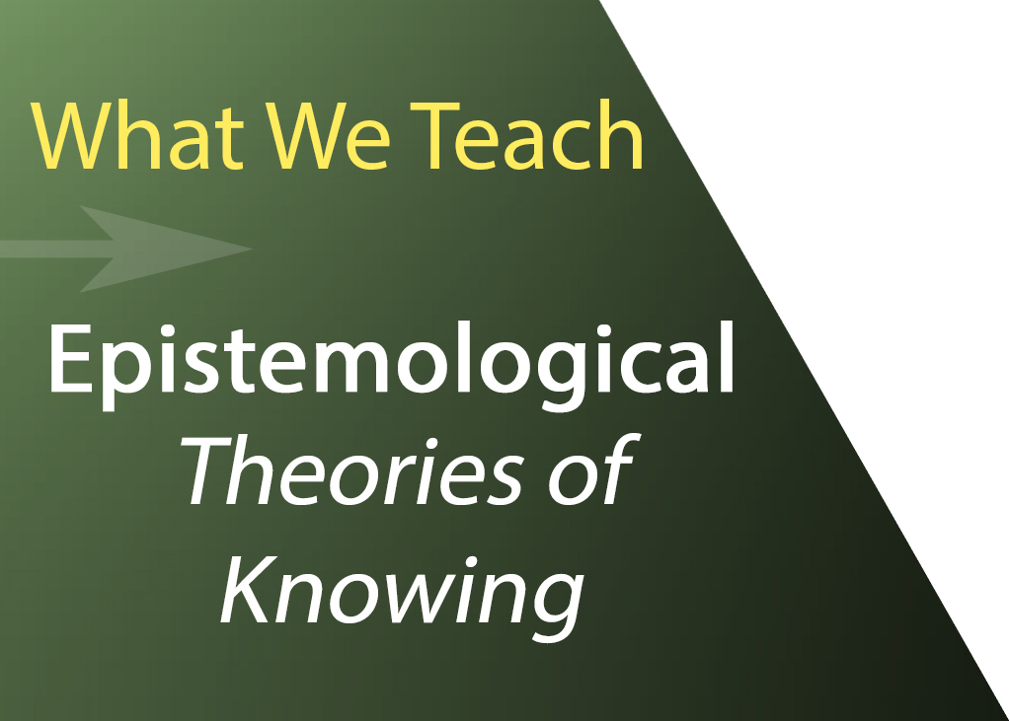II. Theories of Knowledge or The Epistemological Question: What We Teach

This is the area our threefold model that captures most of the integrative projects we described above. In the context of Christian education, discussions of an epistemic nature are often framed around the question of whether truth is essentially unified or are there at least two (or perhaps more) separate and distinct sources of truth.

Typically, this discussion of epistemology revolves around several basic claims. One position claims that all truth is unified, which is at least as old as Augustine who held that wherever Christians find truth it is the Lord’s. On the other hand, many Christians also acknowledge that truth comes to us from at least two sources, revelation and nature, which also has a venerable history and often associated with St. Thomas Aquinas. Furthermore, others argue for a perspectival view of truth, insofar as our ability to know is limited by various aspect of the human condition, such as finitude, the fall, or subjectivity. The issue of separate and distinct sources of truth has been further problematized by the rise of post-Enlightenment disciplinary projects that operate according to methods, epistemologies, and goals that were formulated without reference to Judeo-Christian assumptions. Christians have disagreed over the reality of and relationship between these various sources and they have been understood in almost every imaginable way: as hopelessly opposed, confined to separate categories, different but complementary, or harmoniously convergent. For some, the answers to such epistemic questions are rather straightforward. For others, they are complicated and vexing.

Without discounting the importance of these questions, we would like to reframe the epistemological question in terms of the Biblical narrative arc of the creation, the fall, redemption, and restoration. In addition, we recommend that we focus on the epistemological commitments associated with the disciplines we teach. *What are the epistemic questions embedded in each of disciplines? What counts as knowledge and evidence? What is a valid argument? How do we understand our disciplinary commitments from a specifically Christian positioning? How transparent do we make these questions to our students?*

A. In thinking about the relationship between God’s creation and epistemology, we recommend considering two areas of questions. How does our understanding of being created in God’s image impact our ability to know? In addition, we can ask questions about the nature of God’s creation and our ability to understand it.

Generally, Christians argue that part of our created nature includes a reason and a will. Thus, all people including unbelievers are fully human, and retain the ability to reason to truth and to will the good.

Question to Ponder

*To what degree does our disciplinary epistemological commitments take* imago dei *into consideration?*

Others ask questions about the natural world itself.

Questions to Ponder

*Is the world that God created fully intelligible to us? Is it exactly as it appears to us? Are we limited in our understanding of God’s creation due to its complexity and our finitude? Is there more to God’s creation than can be understood through the senses? Can we know God’s creation objectively or are we limited to our subjective perceptions? How does your discipline answer such questions? How does your understanding of God’s creation intersect with such disciplinary commitments?*

B. What is the relationship between the fall and epistemology? For many, this is a vexing question: because of the fall, our thinking needs to be corrected by truth, yet our perception of what truth is can also be affected by sin. Certainly, these questions should result in a healthy dose of humility.

Questions to Ponder

*In light of the fall, how can we humbly teach to pursue truth?*

*To what degree does the fall corrupt the powers of human reason and moral capacity, calling into question all human intellectual endeavors?*

As Christians, we acknowledge that that the fall penetrates, fragments, and distorts all aspects of the human activity.

In addition, we might think about the effects of the fall in terms of *imago dei.* Even though sin has distorted creation, it has not completely destroyed it.

C. In what ways does God’s work of redemption and restoration affect what we can know? Many Christians argue that it is part of our created nature to be able to receive the grace of God necessary to bring them to the ultimate goal of a saving relationship with God. Others argue that this is impossible in our natural state and can only happen through the agency of the Holy Spirit.

Question to Ponder

*In what ways does your position on these questions figure into your disciplinary understanding of how we know and what we can know?*

Questions to Ponder

*To what degree does the rationality of creation, our creation in the image of God, and the concept of common grace allow us to correctly understand God’s creation and mitigate the effects of the fall?*

*How do the answers to these questions intersect with your disciplinary commitments? Where do the tensions lie? To what degree do we lay these tensions before our students?*

*How does the effect of the fall on human rationality affect our approach to course content and our assessment of student work? How does the reality of our fallen nature affect our expectations of students? How can we support our students’ journey in learning even though we are still sinful?*

Some argue that unbelievers are fully human as beings created in God’s image, possessing ability to know to truth, to create beauty, and to will the good. Others argue that only the regenerate can truly know.

Questions to Ponder

*In what ways does your position on these questions figure into your curriculum choices and your expectations for students?*

*How can we balance achievement standards and expectations with grace? How does the narrative of redemption and restoration play out in your disciplinary epistemological commitments, your choice of content, and your expectations of student understanding?*

**Suggested Reading:**

Blamiers, Harry. *The Christian Mind: How Should a Christian Think?* Ann Arbor: Servant Books, 1963.

Curry, Janel and Ronald Wells, eds. *Faithful Imagination in the Academy: Explorations in Religious Belief and Scholarship.* New York: Lexington Books, 2008.

Gaebelein, Frank. The Pattern of God’s Truth: Problems of Integration in Christian Education. New York: Oxford University Press, 1954.

Knight, George. Philosophy and Education: An Introduction in Christian Perspective. Berrien Springs, IL: Andrews University Press, 2006.

Marsden, George. *The Outrageous Idea of Christian Scholarship.*  New York: Oxford University Press, 1997.

Moreland, J.P. *Love God With All Your Mind: The Role of Reason in the Life of the Soul*. Colorado Springs: NavPress Books, 1997.

Riesen, Richard. *Piety and Philosophy: A Primer for Christian Schools.* Colorado Springs: Purposeful Design Publications, 2009.

Sire, James. *Discipleship of the Mind: Learning to Love God in the Ways We Think*. Downers Grove: InterVarsity Press, 1990.

Sire, James. *The Universe Next Door: A Basic World View Catalog*. Downers Grove: InterVarsity Press, 1990.

Spears, Paul and Steven Loomis. *Education for Human Flourishing: A Christian Perspective.* Downers Grove: InterVarsity Press, 2009.

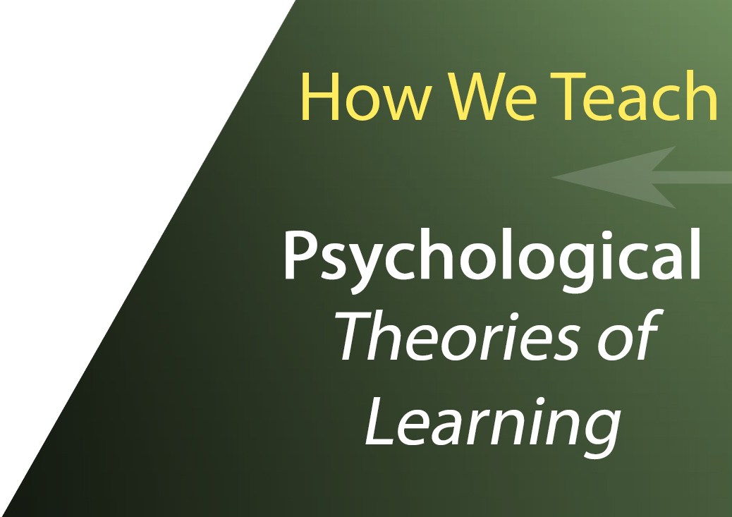III. Theories of Education or The Psychological Question: How We Teach

Learning, like breathing, occurs every minute of the day. Because it seems so natural, learning often goes unnoticed, unexamined. Since learning is such a common experience, we overlook its complexity, leading to misunderstandings about learning and teaching. Every approach to education, to discipleship, to Christian formation, assumes an implicit model of what human being are, and more to the point, what sorts of learners we are. These models of learning are often unarticulated. *How does our understanding of creation, the fall, redemption, and reconstruction influence how we teach and how our students learn?*

We recognize that there exists significant disagreement at various levels among Christians regarding psychology. Since Freud’s own views on religion are well documented, some contend that psychology (generally) or psychoanalytic approaches (specifically) are enemies of the Christian faith and believe we require a completely reconceptualized Christian psychology. Others maintain that psychology is a practical complement to one’s faith. Some are hopeful that psychology can be truly integrative discipline. Among Christian psychologists and scholars, there seems to be an agreement that psychology as a discipline, as a science, and as a practice, is fluid and changing, as are all human endeavors, and with increasing knowledge, research, verification, and correcting, has much to teach us about how our students learn. And if J.P. Moreland over at Biola is correct, it will approach truth. Indeed, recent scholarship suggests that revisions in psychoanalytic theory are moving its foundational premises closer to a Christian view of mankind. Each of us needs to stake our claim in this respect, and then be intentional about the teaching methodologies we employ.

One way to approach educational psychology is to distinguish between theoretical and descriptive psychology. Simply (perhaps a bit crudely) put, theoretical psychology attempts to explain and predict various aspects of human behavior, often based on naturalistic and evolutionary assumptions that many Christians find objectionable. Descriptive psychology, on the other hand, provides a means for describing, distinguishing and categorizing the various aspects that concern persons and their behavior. Descriptive developmental psychology offers important insight into how our students function and mature as learners in at least three areas:

• How do we develop as persons – theories of personality development.

• How do we develop as learners – theories of cognitive development.

• How do we develop as ethical decision makers – theories of moral reasoning development.

We are asking you to carefully reflect on what drives your choice of educational methodologies. Is the answer “Whatever seems to work or gets results?” (The instrumental or utilitarian approach.) Whatever gets us through the day? (The “keep the students busy” approach.) Or perhaps, “This is what we were taught by our master teachers and other mentors?” (Appeal to authority.) Whatever new technology catches our eye? (The market-driven approaches of consume and dispose.) Or, is our choice of educational methodologies driven by a thoughtful understanding of how students learn?

We recommend that WCHS faculty, coaches, student group advisors, program directors, staff, and administration to thoughtfully articulate how we each understand “learning” (v.). We believe that the intersection of descriptive psychological theories on how students learn and of our theological commitment to the biblical narrative arc of creation, the fall, redemption, and restoration can offer rich insight into the lives or our students and ourselves. We must be intentional about our teaching methods in terms of our theological understanding of human personhood, in light of the findings of descriptive educational psychology, and in view of the goals of this mission-driven institution.

A. If we believe that our students are created in God’s image and have considerable worth and value, then we must also recognize that complexity and variety of their psychological nature reflect this marvelous creation and the patterns God created.

Questions to Ponder

*As teachers, how can we take into account that God may have designed humans to mature and develop in particular ways and patterns as we create learning experiences for our students*?

*How can we make use of psychology’s very observant descriptions of the way our students function without accepting naturalistic assumptions of the nature of human beings?*

*How can we use the findings of psychology to bring our students into a more mature relationship with Christ?*

For example, we might ask “*how do we anticipate and even set-up teachable moments*” from developmental perspective. Often, we think about teachable moments as somewhat serendipitous, suggesting a certain flexibility to go with the flow of students. Of course this is an important pedagogical skill. Yet, how can we take this even further to set up or teach our students to ask those good questions. A key concept here is readiness, in that we must discern to what degree are our students both able and willing to handle specific kinds of questions and concepts. Our students particular stages in life tend to develop in them differing interests. This is true for us as well. Development does not end at puberty.

Question to Ponder

*How can we accommodate the variety of student needs in the classroom, without any real loss in terms of content?*

Another approach to learning that has made headway into recent educational models is Howard Gardner’s theory of multiple intelligences. While Gardner’s theories are rooted in naturalistic and evolutionary assumptions, many Christians have understood the concept of multiple intelligences in terms of *imago dei* and spiritual gifts.

Questions to Ponder

*How does Howard Gardner’s particular theory of multiple intelligences describe what constitutes an “intelligence” and how can it inform the selection of our teaching methodologies?*

*What are the implications of multiple intelligences, including the desires, practices, and policies that flow from assumptions about intelligence, impact what is valued, who is “smart,” what is rewarded, where authority rests, and what is “normal” in our classrooms?*

B. Our students and ourselves are affected by sin, at both the personal and the corporate levels of our lives in at least two ways. We are culpable and accountable for sins we have committed individually and collectively. As well, other persons, communities, societies, and various institutions that perpetuate oppressive patterns of life have sinned against us. In psychology, sins and sinful patters are termed dysfunctionalities.

Question to Ponder

*As teachers, how can we take into account the fall as we create learning experiences for our students?*

One question we might ask about how we teach in light of the fall is “*how do we diagnose learning’ problems,’ broadly conceived?*” That is, are they always the fault of the student? What makes this even more difficult to discern is that we teachers are also subject to the same dynamics that affect our students. Confronting the reality that we are fallen should make us even more humble, attentive, thoughtful, and intentional in our selection of learning methodologies.

After the fall, we are in a constant battle to choose the fruits of the spirit over the fruits of the flesh. As James K.A. Smith reminds us, our desires are askew.

Questions to Ponder

*How has the fall and our sinful nature affected what we view as “the good?”*

*How can we teach our students to want the Kingdom?*

*How can we teach well when sin interrupts God’s intended human development?*

*How is our instruction influenced or modified by an awareness of developmental needs, cultural differences and/or the impact of sinful experiences (in both senses)?*

*How is our instruction influenced or modified by an awareness of developmental needs, cultural differences and/or the impact of sinful experiences (in both senses)?*

C. Many, although certainly not all, of our students have been redeemed in Christ. By understanding that an individual student is redeemed and has accepted the Gospel’s message should affect the methods we choose, the discussions we have, and the things we avoid. Likewise, a student who we understand to have not yet accepted the Gospel should cause us to ask the same questions of our methods. Yet, the difficulty occurs in that often times we do not have a completely clear understanding of who we teach when it comes to redemption; therefore, our teaching methods are not going to be as clear.

Questions to Ponder

*How are our teaching methods affected by the “redemption status” of our students?*

*Can or should we expect a student to have the same understanding of a particular concept if they are in a different space in terms of spiritual maturity*?

*How do our teaching methods reflect our sensitivities to the promptings of the Holy Spirit?*

*How do we take our subject and present it in a way that leads our students to desire redemption?*

*How do we as teachers help students to recognize the significance of their redemption and its impact on their lives?*

*How do we help our students appreciate the implications of a school population that is mix of redeemed and un-redeemed?*

D. Our students can and are being recreated and transformed in Christ. They are being restored to become increasingly what God has intended them to be. If what we do in our classrooms matter, then we should be intentionally involved in this restorative process. We are all fallen and then redeemed and consequently on a journey of restoration. We live in a tension between our holy original created states and our sinful humanity, and we are deeply dependent on the agency of God and the work of the Holy Spirit to move us toward His original creation. Yet, each of us on any given day may be more or less in-tune with consciously seeking the direction of the Scriptures and the Holy Spirit.

Questions to Ponder

*In what ways can we shape our classroom environment and select pedagogy that is not just informative but formative?*

*How do we take our subject and present it in a way that leads our students to desire the kingdom?*

*How do we guide students toward a desire to pursue the restoration process in the context of our disciplinary pursuits?*

*How do we allow our students (redeemed and non-redeemed) wrestle with searching their faith?*

*Do we have assignments that non-redeemed students can openly share their searching faith?*

*How do we teach with both redeemed and non-redeemed students in our classes to allow the Holy Spirit to bring about restoration?*

https://ssl.gstatic.com/ui/v1/icons/mail/images/cleardot.gif

**Suggested Reading:**

Gardner, Howard. *Intelligence Reframed: Multiple Intelligences for the 21st Century*. New York: Basic, 1999.

Issler, Klaus and Ronald Habermas. *How We Learn: A Christian Teacher’s Guide to Educational Psychology.* Eugene, OR: Resource Publications, 1994.

Moreland, J.P. and David M. Ciocchi, eds. *Perspectives on Being Human: A Multidisciplinary Approach to Integration.* Grand Rapids: Baker Books, 1993.

McGee, Davis and Bryce Hantla. “An Intelligent Critique of Multiple Intelligences: A Christian Review for Leaders.” *Journal of Biblical Perspectives in Leadership* 4, no. 1 (2012): 3-16.

Pazmino, Robert. *Foundational Issues in Christian Education: An Introduction in Evangelical Perspective.* Grand Rapids: Baker Academic, 1997.

Yount, William. *Created to Learn: A Christian Teacher’s Introduction to Educational Psychology.* Nashville: B&H Academic, 2010.